Follow Up Tool(improvement)

aDDING ORDER OR OFFER
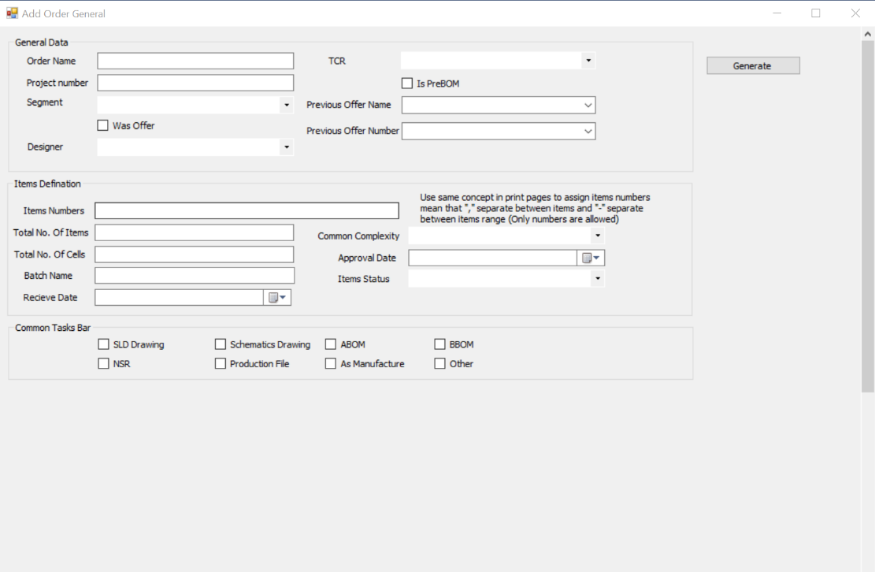
- We need to add feature to read from excel
- Make both previous offer name and number read from already added offers
- Items number should accept characters

For future what i need
- In brief I need to make notification from planner to team leaders about new offers/orders[as below flow chart]

